

K.R. Mangalam University
School of Engineering & Technology

Database Management System
Capstone Report

Submitted by: Submitted to:
Name: Utsah Singhal Dr. Mansi Kajal
Roll no. : 2401010203
Program: B.Tech-CSE
Section – A

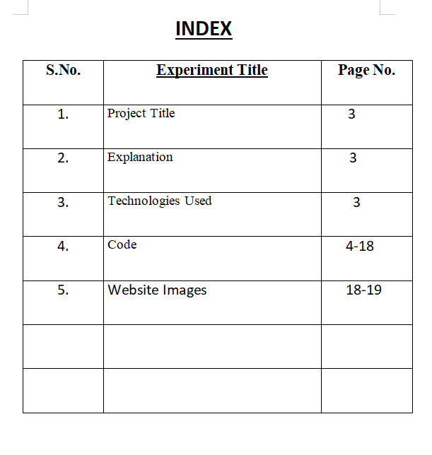

Project Title: Flight Reservation System

- Design a schema to store flight information including routes, schedules, and capacities.

- Implement queries to handle seat availability, booking status, and flight cancellations.

- Handle overbooking situations and prioritize passenger upgrades based on loyalty programs or fare classes.

PROJECT EXPLANATION-
A full-stack DBMS Mini Project that simulates a real-world airline reservation platform.
This project allows users to search flights, view bookings, check seat availability, monitor revenue, and manage passenger data through an interactive web dashboard.

Technologies Used-

Frontend:
- HTML5
- CSS 3
- Java Script

Backend:
- Node.js
- Express.js

Database:
- MySQL

CODE:

HTML
<!DOCTYPE html>
<html lang="en">
<head>
<meta charset="UTF-8">
<meta name="viewport" content="width=device-width, initial-scale=1.0">
<title>SkyFly Airlines | Flight Reservation System</title>

<style>
*{
margin:0;
padding:0;
box-sizing:border-box;
}

body{
font-family:Segoe UI, sans-serif;
background:#020617;
color:white;
}

/* NAVBAR */
.navbar{
display:flex;
justify-content:space-between;
align-items:center;
padding:15px 40px;
background:#0f172a;
border-bottom:1px solid #1e293b;
}

.logo{
font-size:24px;
font-weight:bold;
color:#38bdf8;
}

.nav-links{
display:flex;
gap:25px;
color:#cbd5e1;
}

/* HERO */
.hero{
padding:80px 20px;
text-align:center;
background:
linear-gradient(rgba(0,0,0,0.6), rgba(0,0,0,0.6)),
url('https://images.unsplash.com/photo-1436491865332-7a61a109cc05?auto=format&fit=crop&w=1600&q=80');
background-size:cover;
background-position:center;
}

.hero h1{
font-size:48px;
color:#38bdf8;
}

.hero p{
margin-top:15px;
font-size:18px;
color:#e2e8f0;
}

.hero h3{
margin-top:20px;
color:#94a3b8;
}

/* SEARCH */
.search-box{
display:flex;
justify-content:center;
gap:10px;
margin-top:30px;
flex-wrap:wrap;
}

.search-box input{
padding:12px;
width:220px;
border:none;
border-radius:8px;
}

.search-box button{
padding:12px 20px;
border:none;
border-radius:8px;
background:#38bdf8;
cursor:pointer;
font-weight:bold;
}

/* AIRLINES */
.airlines{
display:flex;
justify-content:center;
gap:30px;
flex-wrap:wrap;
padding:30px;
}

.airlines img{
width:120px;
height:60px;
background:white;
padding:10px;
border-radius:10px;
}

/* BUTTONS */
.buttons{
display:flex;
justify-content:center;
flex-wrap:wrap;
gap:15px;
margin:20px;
}

.card-btn{
background:#1e293b;
border:1px solid #38bdf8;
padding:14px 20px;
border-radius:10px;
cursor:pointer;
transition:0.3s;
}

.card-btn:hover{
background:#38bdf8;
color:black;
transform:scale(1.05);
}

/* DESTINATIONS */
.section-title{
text-align:center;
margin-top:40px;
color:#38bdf8;
}

.destinations{
display:flex;
justify-content:center;
gap:20px;
flex-wrap:wrap;
padding:30px;
}

.card{
width:260px;
background:#1e293b;
border-radius:12px;
overflow:hidden;
}

.card img{
width:100%;
height:170px;
object-fit:cover;
}

.card p{
padding:15px;
text-align:center;
}

/* TABLE */
table{
width:85%;
margin:auto;
border-collapse:collapse;
margin-top:30px;
margin-bottom:60px;
}

th{
background:#1e293b;
color:#38bdf8;
}

td{
background:#020617;
}

td,th{
border:1px solid #334155;
padding:12px;
text-align:center;
}

/* FOOTER */
.footer{
text-align:center;
padding:20px;
color:#64748b;
border-top:1px solid #1e293b;
}
</style>
</head>

<body>

<!-- NAVBAR -->
<div class="navbar">
<div class="logo">✈ SkyFly Airlines</div>
<div class="nav-links">
<span>Home</span>
<span>Flights</span>
<span>Dashboard</span>
<span>Contact</span>
</div>
</div>

<!-- HERO -->
<div class="hero">
<h1>Flight Reservation System</h1>
<p>Search Flights • Manage Bookings • View Revenue</p>
<h3>Created by Utsah Singhal</h3>

<div class="search-box">
<input type="text" id="source" placeholder="From (Delhi)">
<input type="text" id="destination" placeholder="To (Mumbai)">
<button onclick="searchFlights()">Search Flights</button>
</div>
</div>

<!-- BUTTONS -->
<div class="buttons">
<div class="card-btn" onclick="loadFlights()">Flights</div>
<div class="card-btn" onclick="loadWaiting()">Waiting</div>
<div class="card-btn" onclick="loadSeats()">Seats</div>
<div class="card-btn" onclick="loadBookings()">Bookings</div>
<div class="card-btn" onclick="loadRevenue()">Revenue</div>
<div class="card-btn" onclick="loadPending()">Pending</div>
</div>

<!-- POPULAR ROUTES -->
<h2 class="section-title">Popular Routes</h2>

<div class="destinations">

<div class="card">
<img src="https://images.unsplash.com/photo-1598091383021-15ddea10925d?auto=format&fit=crop&w=800&q=80">
<p>Delhi → Mumbai</p>
</div>

<div class="card">
<img src="https://images.unsplash.com/photo-1570168007204-dfb528c6958f?auto=format&fit=crop&w=800&q=80">
<p>Mumbai → Bangalore</p>
</div>

<div class="card">
<img src="https://images.unsplash.com/photo-1558431382-27e303142255?auto=format&fit=crop&w=800&q=80">
<p>Delhi → Kolkata</p>
</div>

</div>

<!-- TABLE -->
<table id="table"></table>

<!-- FOOTER -->
<div class="footer">
© 2026 SkyFly Airlines | DBMS Mini Project
</div>

<script>

/* SEARCH */
function searchFlights(){
const source=document.getElementById("source").value;
const destination=document.getElementById("destination").value;

fetch(`http://localhost:3000/search?source=${source}&destination=${destination}`)
.then(res=>res.json())
.then(data=>{
let html="<tr><th>ID</th><th>Airline</th><th>From</th><th>To</th></tr>";

if(data.length===0){
html+="<tr><td colspan='4'>No Flights Found</td></tr>";
}else{
data.forEach(row=>{
html+=`<tr>
<td>${row.flight_id}</td>
<td>${row.airline}</td>
<td>${row.source}</td>
<td>${row.destination}</td>
</tr>`;
});
}

document.getElementById("table").innerHTML=html;
});
}

/* FLIGHTS */
function loadFlights(){
fetch("http://localhost:3000/flights")
.then(res=>res.json())
.then(data=>{
let html="<tr><th>ID</th><th>Airline</th><th>From</th><th>To</th></tr>";
data.forEach(row=>{
html+=`<tr>
<td>${row.flight_id}</td>
<td>${row.airline}</td>
<td>${row.source}</td>
<td>${row.destination}</td>
</tr>`;
});
document.getElementById("table").innerHTML=html;
});
}

/* WAITING */
function loadWaiting(){
fetch("http://localhost:3000/waiting")
.then(res=>res.json())
.then(data=>{
let html="<tr><th>Name</th><th>Flight</th></tr>";
data.forEach(row=>{
html+=`<tr><td>${row.name}</td><td>${row.flight_id}</td></tr>`;
});
document.getElementById("table").innerHTML=html;
});
}

/* SEATS */
function loadSeats(){
fetch("http://localhost:3000/seats")
.then(res=>res.json())
.then(data=>{
let html="<tr><th>Flight</th><th>Available Seats</th></tr>";
data.forEach(row=>{
html+=`<tr><td>${row.flight_id}</td><td>${row.available_seats}</td></tr>`;
});
document.getElementById("table").innerHTML=html;
});
}

/* BOOKINGS */
function loadBookings(){
fetch("http://localhost:3000/bookings")
.then(res=>res.json())
.then(data=>{
let html="<tr><th>ID</th><th>Name</th><th>Airline</th><th>Status</th></tr>";
data.forEach(row=>{
html+=`<tr>
<td>${row.booking_id}</td>
<td>${row.name}</td>
<td>${row.airline}</td>
<td>${row.status}</td>
</tr>`;
});
document.getElementById("table").innerHTML=html;
});
}

/* REVENUE */
function loadRevenue(){
fetch("http://localhost:3000/revenue")
.then(res=>res.json())
.then(data=>{
let html="<tr><th>Flight</th><th>Revenue</th></tr>";
data.forEach(row=>{
html+=`<tr><td>${row.flight_id}</td><td>${row.revenue}</td></tr>`;
});
document.getElementById("table").innerHTML=html;
});
}

/* PENDING */
function loadPending(){
fetch("http://localhost:3000/pending")
.then(res=>res.json())
.then(data=>{
let html="<tr><th>Passenger</th></tr>";
data.forEach(row=>{
html+=`<tr><td>${row.name}</td></tr>`;
});
document.getElementById("table").innerHTML=html;
});
}

</script>

</body>
</html>

Java Script-

const express = require("express");
const mysql = require("mysql2");
const cors = require("cors");

const app = express();
app.use(cors());
app.use(express.json());

/* =========================
DATABASE CONNECTION
========================= */
const db = mysql.createConnection({
host: "localhost",
user: "root",
password: "BM6259#&",
database: "flightdb"
});

db.connect((err) => {
if (err) {
console.log("Database connection failed");
console.log(err);
} else {
console.log("Connected to MySQL");
}
});

/* =========================
SEARCH FLIGHTS
========================= */
app.get("/search", (req, res) => {
const source = req.query.source?.trim();
const destination = req.query.destination?.trim();

const query = `
SELECT * FROM Flights
WHERE LOWER(TRIM(source)) = LOWER(?)
AND LOWER(TRIM(destination)) = LOWER(?)
`;

db.query(query, [source, destination], (err, result) => {
if (err) {
res.send(err);
} else {
res.json(result);
}
});
});

/* =========================
ALL FLIGHTS
========================= */
app.get("/flights", (req, res) => {
db.query("SELECT * FROM Flights", (err, result) => {
if (err) {
res.send(err);
} else {
res.json(result);
}
});
});

/* =========================
WAITING PASSENGERS
========================= */
app.get("/waiting", (req, res) => {
const query = `
SELECT p.name, b.flight_id
FROM Bookings b
JOIN Passengers p
ON b.passenger_id = p.passenger_id
WHERE b.status = 'Waiting'
`;

db.query(query, (err, result) => {
if (err) {
res.send(err);
} else {
res.json(result);
}
});
});

/* =========================
SEAT AVAILABILITY
========================= */
app.get("/seats", (req, res) => {
const query = `
SELECT f.flight_id,
f.capacity - COUNT(b.booking_id) AS available_seats

FROM Flights f

LEFT JOIN Bookings b
ON f.flight_id = b.flight_id
AND b.status = 'Confirmed'

GROUP BY f.flight_id, f.capacity
`;

db.query(query, (err, result) => {
if (err) {
res.send(err);
} else {
res.json(result);
}
});
});

/* =========================
BOOKING DETAILS
========================= */
app.get("/bookings", (req, res) => {
const query = `
SELECT b.booking_id,
p.name,
f.airline,
b.status

FROM Bookings b

JOIN Passengers p
ON b.passenger_id = p.passenger_id

JOIN Flights f
ON b.flight_id = f.flight_id
`;

db.query(query, (err, result) => {
if (err) {
res.send(err);
} else {
res.json(result);
}
});
});

/* =========================
REVENUE
========================= */
app.get("/revenue", (req, res) => {
const query = `
SELECT f.flight_id,
SUM(pay.amount) AS revenue

FROM Flights f

JOIN Bookings b
ON f.flight_id = b.flight_id

JOIN Payments pay
ON b.booking_id = pay.booking_id

WHERE pay.payment_status = 'Paid'

GROUP BY f.flight_id
`;

db.query(query, (err, result) => {
if (err) {
res.send(err);
} else {
res.json(result);
}
});
});

/* =========================
PENDING PAYMENTS
========================= */
app.get("/pending", (req, res) => {
const query = `
SELECT DISTINCT p.name

FROM Payments pay

JOIN Bookings b
ON pay.booking_id = b.booking_id

JOIN Passengers p
ON b.passenger_id = p.passenger_id

WHERE pay.payment_status = 'Pending'
`;

db.query(query, (err, result) => {
if (err) {
res.send(err);
} else {
res.json(result);
}
});
});

/* =========================
START SERVER
========================= */
app.listen(3000, () => {
console.log("Server running on port 3000");
});

MySQL:
CREATE DATABASE FlightDB;
USE FlightDB;CREATE TABLE Flights (
flight_id INT PRIMARY KEY,
airline VARCHAR(50),
source VARCHAR(50),
destination VARCHAR(50),
departure_time DATETIME,
arrival_time DATETIME,
capacity INT,
status VARCHAR(20) DEFAULT 'On Time'
);
CREATE TABLE Passengers (
passenger_id INT PRIMARY KEY,
name VARCHAR(50),
age INT,
gender VARCHAR(10),
loyalty_points INT
);
CREATE TABLE Bookings (
booking_id INT PRIMARY KEY,
passenger_id INT,
flight_id INT,
seat_number VARCHAR(5),
status VARCHAR(20),
FOREIGN KEY (passenger_id) REFERENCES Passengers(passenger_id),
FOREIGN KEY (flight_id) REFERENCES Flights(flight_id)
);
CREATE TABLE Payments (
payment_id INT PRIMARY KEY,
booking_id INT,
amount DECIMAL(10,2),
payment_status VARCHAR(20),
FOREIGN KEY (booking_id) REFERENCES Bookings(booking_id)
);
INSERT INTO Flights VALUES
(1, 'IndiGo', 'Delhi', 'Mumbai', '2026-04-01 10:00:00', '2026-04-01 12:00:00', 5, 'On Time'),
(2, 'Air India', 'Mumbai', 'Bangalore', '2026-04-02 14:00:00', '2026-04-02 16:30:00', 3, 'On Time'),
(3, 'Vistara', 'Delhi', 'Kolkata', '2026-04-03 09:00:00', '2026-04-03 11:30:00', 4, 'On Time'),
(4, 'SpiceJet', 'Chennai', 'Delhi', '2026-04-04 18:00:00', '2026-04-04 21:00:00', 2, 'On Time');
INSERT INTO Passengers VALUES
(1, 'Utsav', 20, 'Male', 100),
(2, 'Rahul', 25, 'Male', 50),
(3, 'Sneha', 22, 'Female', 200),
(4, 'Amit', 30, 'Male', 30),
(5, 'Neha', 28, 'Female', 150),
(6, 'Karan', 27, 'Male', 80),
(7, 'Pooja', 24, 'Female', 120);
INSERT INTO Bookings VALUES
(1, 1, 1, 'A1', 'Confirmed'),
(2, 2, 1, 'A2', 'Confirmed'),
(3, 3, 1, 'A3', 'Confirmed'),
(4, 4, 1, 'A4', 'Confirmed'),
(5, 5, 1, 'A5', 'Confirmed'),
(6, 6, 1, 'A6', 'Waiting'),

(7, 2, 2, 'B1', 'Confirmed'),
(8, 3, 2, 'B2', 'Confirmed'),
(9, 4, 2, 'B3', 'Confirmed'),

(10, 5, 3, 'C1', 'Confirmed'),
(11, 6, 3, 'C2', 'Confirmed'),

(12, 7, 4, 'D1', 'Confirmed'),
(13, 1, 4, 'D2', 'Confirmed'),
(14, 2, 4, 'D3', 'Waiting');
INSERT INTO Payments VALUES
(1, 1, 5000.00, 'Paid'),
(2, 2, 5000.00, 'Paid'),
(3, 3, 5000.00, 'Paid'),
(4, 4, 5000.00, 'Paid'),
(5, 5, 5000.00, 'Paid'),
(6, 6, 5000.00, 'Pending'),

(7, 7, 4500.00, 'Paid'),
(8, 8, 4500.00, 'Paid'),
(9, 9, 4500.00, 'Paid'),

(10, 10, 6000.00, 'Paid'),
(11, 11, 6000.00, 'Paid'),

(12, 12, 5500.00, 'Paid'),
(13, 13, 5500.00, 'Paid'),
(14, 14, 5500.00, 'Pending');
SELECT f.flight_id, capacity - COUNT(b.booking_id) AS available_seats
FROM Flights f
LEFT JOIN Bookings b ON f.flight_id = b.flight_id AND b.status='Confirmed'
GROUP BY f.flight_id, capacity;
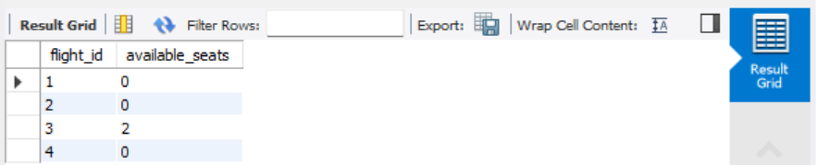
SELECT b.booking_id, p.name, f.airline, b.status
FROM Bookings b
JOIN Passengers p ON b.passenger_id = p.passenger_id
JOIN Flights f ON b.flight_id = f.flight_id;
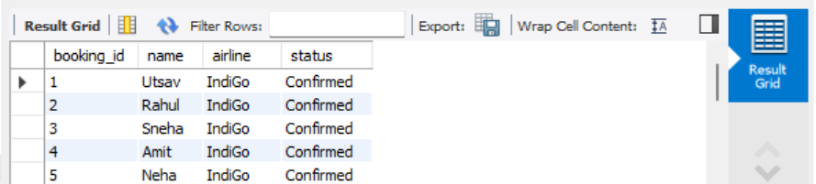
UPDATE Flights
SET status = 'Cancelled'
WHERE flight_id = 2;

SELECT f.flight_id, COUNT(*) AS total_bookings, capacity
FROM Flights f
JOIN Bookings b ON f.flight_id = b.flight_id
GROUP BY f.flight_id
HAVING COUNT(*) > capacity;
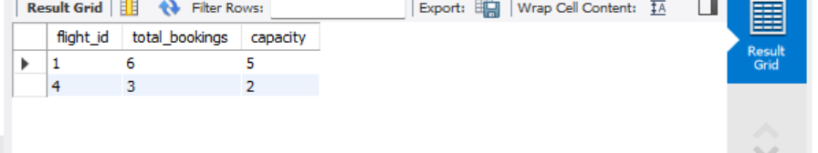
SELECT name, loyalty_points
FROM Passengers
ORDER BY loyalty_points DESC;
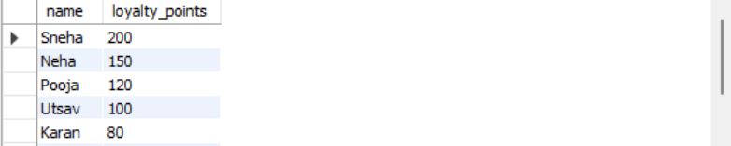
SELECT f.flight_id, SUM(p.amount) AS revenue
FROM Flights f
JOIN Bookings b ON f.flight_id = b.flight_id
JOIN Payments p ON b.booking_id = p.booking_id
WHERE p.payment_status = 'Paid'
GROUP BY f.flight_id;
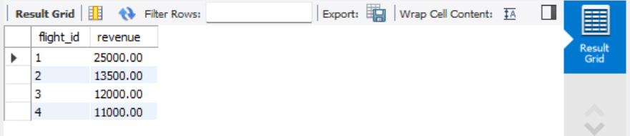
SELECT p.name, b.flight_id
FROM Bookings b
JOIN Passengers p ON b.passenger_id = p.passenger_id
WHERE b.status = 'Waiting';
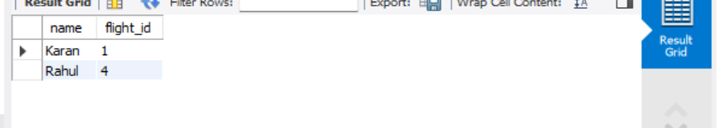

Website-

